💡Navigate between Idea, Thumbnail, Script, and Edit. Choose “View > Expand tabs and outlines sidebar”.
💡Allow commenting access. Choose "File > Make a copy." On the new file, choose "Share > General Access > Anyone with the link > Commenter".

Idea

Audience
Name: Mark
Age: 25+

🌟 Hopes 🌟  What are their short-term aspirations? | 👻 Fears 👻  What fears prevent action?
- To learn a simpler entry point into monetizing AI workflows without the heavy stress of running an agency.  - To start making real income quickly even without quitting their job.  - To gain confidence and proof of skill by solving real problems for businesses.  - To position themselves as an expert consultant instead of just a freelancer-for-hire. | - Not knowing how to scope, price, or communicate value properly, and losing credibility with clients.  - Clients expecting AI to be “magic” fixes for broken businesses, leading to bad relationships and pressure.  - Being seen as just a cheap tech implementer instead of a trusted advisor.  - Falling behind as AI tools evolve so fast that their skills may quickly look outdated.
💭 Dreams 💭  What are their long-term dreams? | 🚧 Blockers 🚧  What blocks them from acting?
- To become a trusted AI consultant that businesses look to for strategy and execution.  - To charge premium prices for workflows and eventually package expertise into $10k+ solutions.  - To eventually scale by having the skills, systems, and reputation to build a lean, profitable consulting business.  - To land recurring consulting retainers or revenue-share deals that create financial stability. | - Lack of initial proof/results  - Confidence gap — unsure they can deliver consistently without over-promising.  - Not knowing which industry or problem to focus on first.

Video Idea - How I Sell AI Workflows Without an Agency / Forget AI Agencies. This AI workflow Model Prints Money on Autopilot / Sell Your AI Workflows Without Running an Agency (the only way)
The value proposition, hook, or compelling reason to watch the video
- This video introduces AI consulting as the smarter path to selling AI workflows without the stress of running an agency. Instead of juggling multiple clients and delivery teams, viewers learn how to start solo, land their first workflow projects, and position themselves as trusted experts who get paid for strategy and outcomes rather than just tasks.

- Expected Takeaway: Understand why agencies are a trap for beginners, how freelancing builds proof and case studies, and how to transition into consulting where you can charge $10k+ for solutions. Viewers will leave with a roadmap to package and sell workflows as high-value business results, build credibility, and secure ongoing consulting opportunities.

Thumbnail

Creative
Written ideas to visualize the hook
- 
- 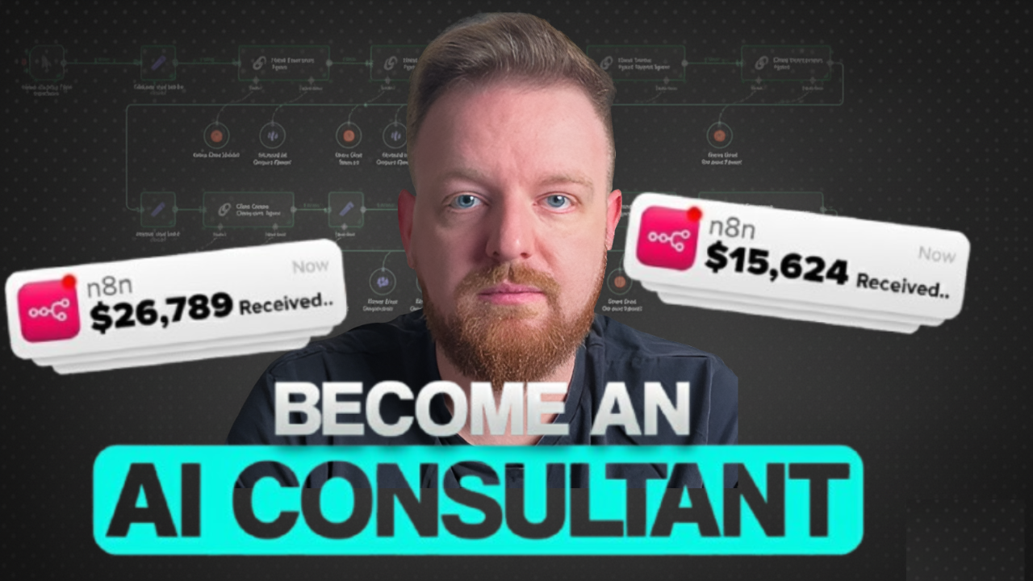

Leverage
Screenshots of proven thumbnails from your niche

 | 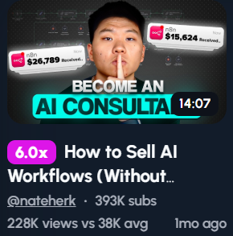 | 

Initiate
Screenshots of your thumbnail versions (include preview from https://thumbnailpreview.com/, not the image alone)
 |  | 

Script

Intro
- In 2025, AI agencies are dying, not just because of new AI tools like make. replacing established agencies, but also the fact that endless client calls, managing a team of 10 and 24/7 stress, is a recipe for an early grave for any AI agency owner.
- But now we have a problem, you know your workflows make money but how do you sell them without running into all the issues that come with running an AI agency?
- In this video I’ll break down how to escape the afterlife and make even more money than you ever could as an AI agency through a new model I call the Vibe Consulting Model.

Remainder
Creative Bridge/Transition: But first let me really show you why agencies are absolutely cooked for beginners right now and how AI consulting is the faster path to $10K+ months.

Why starting an agency is the wrong first move
Setup: Everyone thinks "agency" sounds more legitimate than "consultant." But what if that thinking is costing you money and freedom?
Tension:
- (1) Agencies require managing multiple clients simultaneously, which means coordination chaos
- (2) You become responsible for delivery teams, quality control, and client expectations at scale
- (3) The overhead of hiring, training, and managing people eats your profit margins
- (4) Client work becomes operational management instead of the strategic work you actually enjoy
- (5) What if you could make the same money without any of the management headaches?
Subscribe CTA: By the way, If you want to build an AI business that gives you freedom instead of just more complexity, hit subscribe — I break down the solo consultant path that actually works every week.
Transition: Here's the model that's working: position yourself as an AI workflow consultant who sells expertise, not execution.

The "strategy over execution" positioning that changes everything
Setup: Most people sell AI workflow implementation. Smart consultants sell the blueprint and let someone else build it.
Tension:
- (1)Use your current industry expertise which gives you a moat and speed
- Your service is auditing their processes and designing the AI workflow solution
- (2) You deliver detailed documentation: process maps, tool recommendations, implementation specs
- (3) They handle implementation internally or hire someone to execute your plan
- (4) You charge $5K-15K for strategy work that takes 10-20 hours instead of $3K for 40+ hours of implementation
- (5) How much better would your margins be if you sold thinking instead of doing?
Transition: But here's the part most people struggle with: how do you prove you can solve problems without showing completed implementations?

Building credibility through strategic partnerships (no case studies needed)
Setup: You don't need years of case studies to start consulting. You need to leverage other people's implementations and position yourself as the strategic orchestrator.
Tension:
- (1) Partner with technical implementers who have the portfolio but lack client acquisition skills
- (2) Position yourself as the "strategy layer" — you audit, design, and manage the relationship while partners execute
- (3) Their past work becomes your proof of capability: "Here's what my implementation team has delivered for clients like you"
- (4) You take credit for the strategic thinking and client outcomes, they take credit for technical execution
- (5) What if you could start consulting today by becoming the front-end for talented builders who hate sales?
Transition: Now let's talk about pricing in a way that doesn't scare prospects or leave money on the table.

The three-tier pricing model that eliminates objections
Setup: When you only offer one price, prospects either say yes or no. When you offer three options, they choose which one fits their budget.
Tension:
- (1) Bronze - Workflow Audit & Strategy ($5K-10K): Identify automation opportunities, prioritize quick wins, deliver strategic roadmap with tool recommendations
- (2) Silver - Full Implementation & Oversight ($12K-50K): Complete workflow build-out, tool integration, team training, and quality assurance until systems are live
- (3) Gold - Ongoing AI Infrastructure Management ($5K-8K/month per thing): Recurring retainer for continuous optimization, monitoring, updates, new automation opportunities, and ensuring your AI systems evolve with your business
- (4) Most clients start with Bronze, upgrade to Silver for execution, then stay on Gold for the recurring revenue stream that protects their investment
- (5) How much easier would sales conversations be if clients saw this as a natural progression from strategy to implementation to long-term partnership, rather than a one-and-done transaction?
Transition: But pricing right only matters if you can communicate value properly. Here's the framework that closes deals.

The ROI conversation framework that justifies premium pricing
Setup: Clients don't buy AI workflows. They buy time savings, cost reductions, and revenue increases. Your job is quantifying the business impact.
Tension:
- (1) Calculate current cost: "Your team spends 20 hours per week on manual data entry at $25/hour = $26K annually"
- (2) Quantify opportunity cost: "That's time not spent on revenue-generating activities worth $X"
- (3) Present the solution: "This workflow eliminates 18 of those 20 hours, saving $23K per year"
- (4) Frame your fee as investment: "My $10K fee pays for itself in 5 months, then it's pure savings"
- (5) What if every sales conversation started with their problems costing them money right now?
Transition: Now, once you've mastered positioning and pricing, here's how you find clients.

The "educational authority" method that attracts ideal clients
Setup: Instead of chasing prospects, what if you built a reputation that made them come to you?
Tension:
- (1) Publish detailed breakdowns of specific workflow solutions in specific industries
- (2) Create free resources: "The Small Business AI Automation Audit Template"
- (3) Share behind-the-scenes looks at how you approach problem-solving
- (4) Write case studies of problems you've solved (even hypothetical ones)
- (5) How many ideal clients would reach out if they saw you solving problems exactly like theirs?
Transition: But content marketing takes time. Here's the faster path to your first few paying clients.

The "free pilot project" strategy that builds proof fast
Setup: The fastest way to get testimonials and case studies is offering strategic value upfront to the right prospects.
Tension:
- (1) Identify 3-5 businesses in your target market with obvious workflow inefficiencies
- (2) Reach out with specific value: "I noticed your team manually processes leads. I'd love to audit your workflow for free and show you what's possible"
- (3) Deliver a mini-audit: identify 2-3 automation opportunities with rough ROI calculations
- (4) Ask for testimonial and permission to use as case study in exchange for free work
- (5) What if you could build credibility with 20 hours of strategic work instead of months of content creation?
Transition: Now, once you have proof and clients, here's how to transition from projects to predictable recurring revenue.

The consulting retainer model that creates financial stability
Setup: One-off projects are great for cash flow, but retainers are what let you build a real consulting business.
Tension:
- (1) After delivering a workflow strategy, offer ongoing advisory: "AI Strategy Retainer - $2K-5K/month"
- (2) Monthly deliverables: review new AI tools, identify new automation opportunities, optimize existing workflows
- (3) Position it as insurance: "The AI landscape changes monthly. I keep you ahead of the curve"
- (4) Each retainer client becomes predictable income while requiring only 5-10 hours monthly
- (5) How much more confident would you feel with $10K-20K in recurring revenue before you even pitch new projects?
Transition: But here's what separates consultants who cap at $10K/month from those who hit $50K+: premium positioning.

Becoming the specialist who commands premium rates
Setup: Generalist consultants compete on price. Specialist consultants create categories where they're the only option.
Tension:
- (1) Pick one industry vertical and become the AI workflow expert for that space
- (2) Develop proprietary frameworks: "The [Industry] AI Readiness Assessment"
- (3) Speak the language of that industry fluently — understand their unique pain points
- (4) Build a portfolio of case studies all within that same vertical
- (5) How much easier is it to charge $15K when you're the only AI consultant who truly understands their business?
Transition: And here's the part that protects you from AI tools evolving faster than your skills.

Future-proofing your consulting business against AI evolution
Setup: The biggest fear people have is that AI tools will get so easy that consulting becomes unnecessary. But here's why that's backwards thinking.
Tension:
- (1) As AI tools get easier, more businesses attempt DIY implementations and create expensive messes
- (2) Your value shifts from technical knowledge to strategic judgment and business understanding
- (3) Tools commoditize, but knowing which tool to use and how to integrate it into business processes never does
- (4) The consultant who understands business problems will always beat the one who just knows tools
- (5) What if getting better at business strategy matters more than staying current on every AI tool?
Transition: Finally, here's the biggest mistake I see consultants make that kills their business before it starts.

The confidence trap: waiting until you're "ready"
Setup: The gap between your current skills and where you think you need to be is costing you months of income and learning.
Tension:
- (1) You don't need to master every AI tool before selling workflow consulting
- (2) You need to be one step ahead of your clients, not ten steps ahead
- (3) The best learning happens through paid client work, not free tutorials
- (4) Imposter syndrome doesn't go away with more knowledge — it goes away with more results
- (5) What if the clients you're avoiding because you feel unready would be perfectly satisfied with your current expertise?
Transition: Look, the AI workflow opportunity is massive, but the window for positioning yourself early is closing fast.

Ending CTA
Right now, you can establish yourself as the expert, build proof, and charge premium rates before competition forces prices down. If you want to see the exact consulting frameworks, pricing templates, and client acquisition strategies I use to land $10K+ projects, feel free to join my community below.

